臺北市立大安高工100學年度第1學期期末測驗
年級 | 高二 | 科目 | 英文 | 班級 |  | 座號 |  | 姓名

- 聽力 10% (每題1分)
Part A
In Part A, you will see three pictures on your test paper. For each picture, you will be asked one question. For each question, you will hear three possible answers. Choose the best answer according to what you see in the picture.
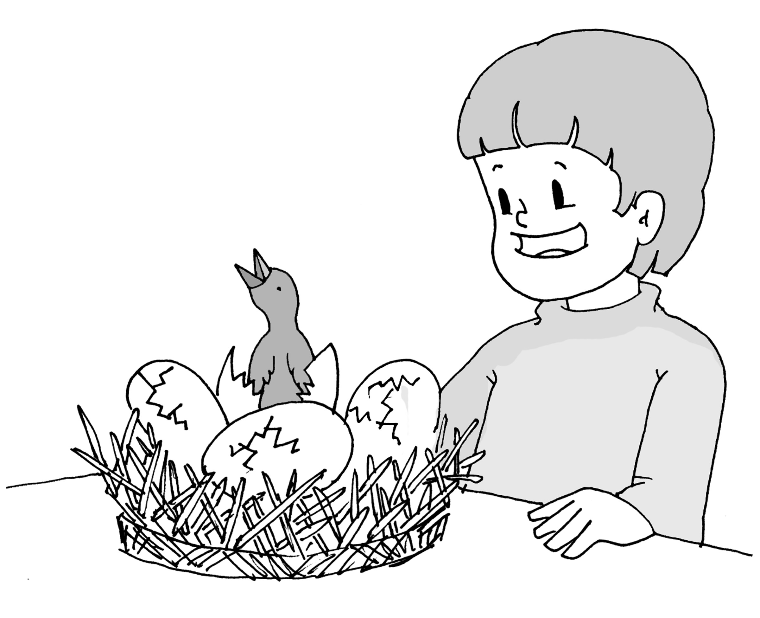
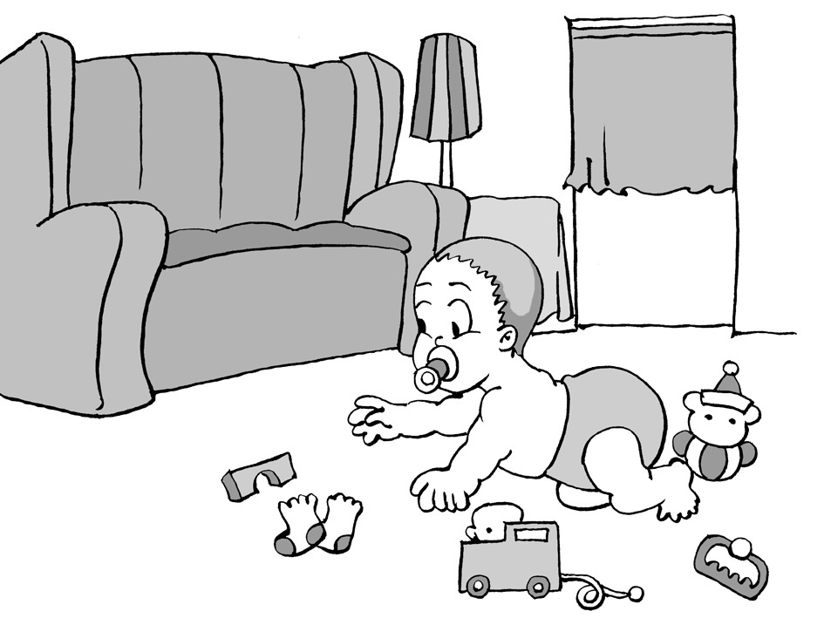

A

B

- ( A ) 2. ( C )
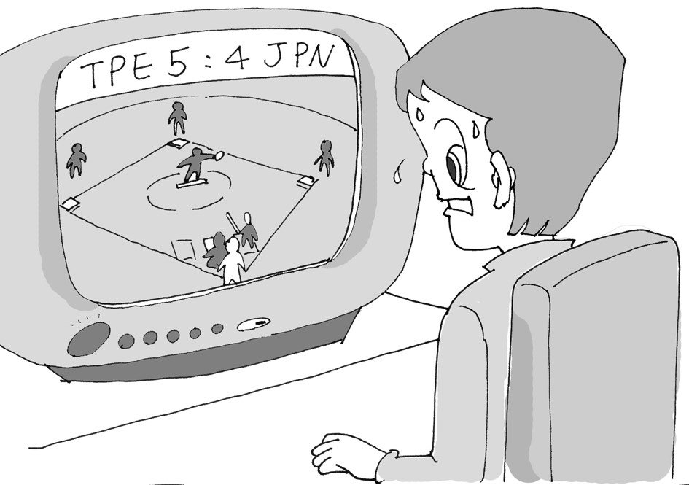

C

- ( B )

Part B
In Part B, you will hear three questions or statements. After you hear a question or statement, read the three possible answers on your test paper and decide which one is the best answer to the question or statement you have heard.

C 4. (A) I get too nervous in public.
(B) Only a little bit.
(C) Yes, I can speak Spanish very well.

A 5. (A) It is from the 1800s.
(B) It looks like it is around noon.
(C) It was taken by my father.

B 6. (A) It is nice of them to give you a ride.
(B) Don't worry. They'll be going home soon.
(C) What are you going shopping for?

Part C
In Part C, you will hear four conversations between a man and a woman. After each conversation, you will hear a question about the conversation. After you hear the question, read the three possible answers on your test paper and choose the best answer to the question you have heard.

B 7. (A) The woman should change her hairstyle.
(B) The woman should relax more.
(C) The woman should try to make more friends.

C 8. (A) It is fun to act like a kid.
(B) Looking at each other's art is fun.
(C) It is fun to make art.

A 9. (A) He makes a lot of noise while sleeping.
(B) He doesn't clean up the house.
(C) He drives his car crazily.

C 10. (A) He always surprises her.
(B) He is very rich.
(C) He is happy to give.

- 字彙片語測驗 20% (每題1分)
B 11. Farmers in this developed country have become a(n) _____; they make up only two percent of the total population.
(A) majority (B) minority (C) activity (D) experience
D 12. It has been raining for six days _____; people have not been able to go out for exercise over the past week.
(A) in the short run (B) in the long run (C) on purpose (D) on end
A 13. Scientists have done much _____ on our brains in order to have a better understanding of their structure.
(A) research (B) study (C) pollution (D) conduct
D 14. Timmy has been raised by his uncle since his parents _____ in an unexpected accident.
(A) gave in (B) sat back (C) fell through (D) passed away
C 15. John wants to _____ the old furniture that unnecessarily takes up a lot of space in his living room.
(A) use up (B) throw up (C) get rid of (D) put out of
C 16. As the final exam is drawing near, students are feeling more and more _____.
(A) underground (B) underpass (C) under stress (D) under the weather
A 17. My grandfather is advised to have_____ exercise in order to control his weight and to increase his quality of sleep.
(A) regular (B) original (C) explosive (D) brief
C 18. Although Kevin’s life is_____ difficulty, he still remains positive about his future.
(A) filled up (B) filled of (C) full of (D) full with
B 19. The winner of this speech contest had a lot of _____in what she said when making her speech.
(A) company (B) confidence (C) courage (D) contact
C 20. Americans are legally allowed to possess guns to _____ themselves.
(A) replace (B) promise (C) defend (D) confirm
B 21. AIDS is a _____ that cannot be cured by any medicine.
(A) combination (B) disease (C) contact (D) pit
D 22. I was surprised to find out that Martha had a brother because she had never _____ him before.
(A) threatened (B) invented (C) blamed (D) mentioned
C 23. We need more people to help _____ the tables and chairs for the party tonight.
(A) portray (B) consume (C) arrange (D) inform
B 24. Scooters and motorcyles are a major _____ of transportation for many people in Taiwan.
(A) construction (B) means (C) pollution (D) solution
D 25. David enjoys walking on a warm, sandy beach in his_____ feet.
(A) mere (B) rare (C) needy (D) bare
B 26. I am much more_____ to life in the U.S than a year ago.
(A) pleased (B) adapted (C) suffered (D) involved
C 27. Andrew’s parents were_____ about their son’s safety in Japan after they had heard of the huge earthquake.
(A) contacted (B) continual (C) concerned (D) convenient
B 28. The magic show really _____ because I had never seen anything like it before.
(A) kept my distance (B) blew my mind (C) made my fortune (D) wasted my time
A 29. My wife will _____ if she finds out that I went gambling instead of fishing.
(A) bite my head off (B) follow in my footsteps
(C) make my debut (D) blow my nose
D 30. There are both strengths and weaknesses for an all-boy or all-girl school. One of the _____ is that students in such a school can focus more on their studies.
(A) advertisements (B) passages (C) arrangements (D) advantages
- 文法20% (每題2分)
C 31. Only by hard work and correct methods _____ succeed.
(A) we can (B) we can’t (C) can we (D) can’t we
A 32. Let’s go biking around Taiwan this winter vacation, _____?
(A) shall we (B) don’t we (C) shouldn’t we (D) can we
B 33. Beside my house _____.
(A) a supermaket is (B) is a supermaket (C) a supermarket is there (D) has a supermarket
D 34. People who often exercise and eat right seldom catch a cold, _____?
(A) don’t they (B) should they (C) shouldn’t they (D) do they
C 35. Out from the room _____.
(A) came she (B) did she come (C) she came (D) did come she
A 36. Mr. Anderson wants to know _____ you can attend the meeting tomorrow.
(A) if (B) because (C) that (D) so that
D 37. Can you tell me _____?
(A) what she lives (B) where to live (C) what to live (D) where she lives
C 38. I don’t think she is a teacher, _____?
(A) isn’t she (B) doesn’t she (C) is she (D) does she
A 39. No matter _____ difficult the situation was, David did not give up or make any complaint.
(A) how (B) why (C) what (D) where
B 40. Sam exercises almost every day _____ he can stay fit.
(A) for (B) so that (C) because (D) unless
- 綜合測驗 32% (每題2分)
- The Yenshui Fireworks Festival has been called the craziest festival—and the most dangerous— in the world. It’s on the same day as the Lantern Festival (41) tens of thousands of people crowd into the small town of Yenshui, just so that they can be attacked by firecrackers! The firecrackers, or bottle rockets, are (42) on very big racks. The biggest of the racks, (43) the firecrackers are set up, can hold up to 20,000 bottle rockets. When they are lit, it is almost impossible for people to avoid getting hit. (44), they have to protect themselves. Most of the people at the Yenshui Fireworks Festival arrive fully (45), wearing motorcycle helmets, face masks, etc. For many Taiwanese, the festival, (46) fifteen days after Chinese New Year, is indeed a crazy way to start off the year!
A 41. (A) when (B) how (C) which (D) why
B 42. (A) put off (B) set off (C) lit off (D) run off
B 43. (A) which (B) on which (C) to which (D) by which
D 44. (A) In the end (B) On the average (C) By no means (D) As a result
C 45. (A) prepare (B) preparing (C) prepared (D) to prepare
C 46. (A) holding (B) which holds (C) held (D) which held
- For most people, tests mean butterflies in their stomach. But (47), tests could be something to hope for. Researchers in the U.S. had an experiment with two groups of students. Each group had to read a passage. One group then reread the passage three times while (48) took three tests on the passage without rereading it. Both groups are tested to find out (49) each group remembered about the passage. It (50) that the students who reread the passage had an (51) the students who were tested on it. However, when a test was given a week later, the students who had been tested several times remembered much more than their counterparts. Such a result shows that, in instead of fearing tests, we can (52) them.
A 47. (A) believe it or not (B) in other words (C) on the one hand (D) simply put
B 48. (A) another (B) the other (C) others (D) the others
D 49. (A) why (B) when (C) which information (D) how much
C 50. (A) lights up (B) runs up (C) turns out (D) comes up
B 51. (A) effect on (B) advantage over (C) insistence on (D) announcement of
A 52. (A) look forward to (B) watch out for (C) conduct research on (D) pay attention to
C. Jennifer got a part-time job babysitting two little boys. At first, she (53) this job. However, after seeing how mischievous those kids were, she totally freaked out. One of the boys put their cat in the washing machine, and neither of the kids (54) on the poor cat. Jennifer didn’t know what to do so she asked her mother for help. Her mother (55) what can be done in such a situation. Thanks to her mother’s help, Jennifer was able to (56) her job.
C 53. (A) depended on (B) saved up (C) delighted in (D) came across
A 54. (A) took pity (B) ran wild (C) put a test (D) had confidence
B 55. (A) solved (B) demonstrated (C) investigated (D) tackled
B 56. (A) go on to (B) stick to (C) have enough of (D) keep track of

- 閱讀測驗10% (每題2分)

The Rolex Sydney Hobart Yacht Race is one difficult yacht race. Taking place on Boxing Day, the race sets off from Sydney, Australia to Hobart on the island of Tasmania. Since the first race in 1945, yachts and their crews have set new speed records in the race. The current record holder finished the 1,170-kilometer course in one day, 18 hours, 40 minutes, and 10 seconds. That is definitely an impressive record, especially when many yachts fail to reach the finish line every year. There are sections where the seas are troubled, difficult, and even dangerous. In 1998, five boats sank, killing six people. Since then, the rules have been changed to ensure that each crew is well-equipped and experienced enough to compete. Given the risks of the challenge, the Rolex Sydney Hobart Yacht Race is anything but relaxing.

A 57. How long has the race been held?
(A) For more than 60 years.
(B) For 45 years.
(C) For one day, 18 hours, 40 minutes, and 10 seconds.
(D) For 1,170 kilometers.

B 58. What is the most challenging part of the race?
(A) There are many skilled contestants.
(B) There are sections where the seas are unstable.
(C) The whole course is extremely long.
(D) There are man-made obstacles along the course.

C 59. Which of the following led to a change in the rules?
(A) Boats were attacked by sharks.
(B) Boats exploded.
(C) People were killed during the race.
(D) People went missing for several days.

Emile Durkheim, a sociologist of the nineteenth century, collected and analyzed data from a number of countries that kept records on suicides. He concluded that social environment should have a strong effect on those behaviors we consider most personal. The results of his study showed that suicide rates do indeed vary according to specific social characteristics. For example, Durkheim found out that members of religions with strong prohibitions against suicide are less likely to commit suicide than are members of religious groups with weaker prohibitions. Rules in certain religions, in a way, restrict people from killing themselves. He also found a lower incidence of suicide among married persons than among persons who were single or divorced. Taken together, Durkheim's study provided convincing evidence that social groups indeed have influences that control the behavior of individuals, including deeply personal behaviors.

C 60. Which of the following best expresses the main idea of the passage?
(A) The social theory developed by Durkheim has contributed to the field of sociology.
(B) Durkheim believed that individuals of a group strongly influence the group's behavior.
(C) Durkheim’s research provided evidence that suicide rates vary among members ofdifferent social groups.
(D)Through his research, Durkheim made a lot of progress in sociology.

A 61. Which of the following best defines the word, “prohibitions,” underlined in the reading?
(A) Restrictions.
(B) Solutions.
(C) Data.
(D) Security.
- 連貫式翻譯8% (每題4分)
  - 說到台灣的元宵節，我們很容易就想到鹽水蜂炮。
When it comes to the Lantern Festival in Taiwan, the Yanshui Fireworks come to our minds easily.
  - 這個施放鞭炮的習俗可以追溯至1875年，當時一個不知名的疾病侵襲鹽水。
This custom of setting firecrackers can date back to 1875 when an unknown disease struck Yanshui.

