(Worksheet 1) Look, Copy and Write 先摹寫再造句
you
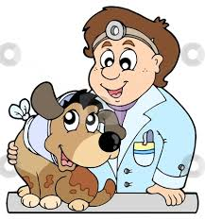
1.
What do you want to be?

__________________________________

I want to be a vet.
you
__________________________________
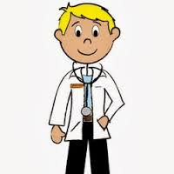
2.
What

I
Sam

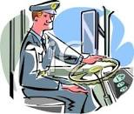
3.
What does Sam want to be?
__________________________________

He wants to be a bus driver.
__________________________________
Jenny

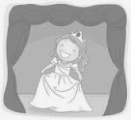
4.
What

She

(Worksheet 2) Look, Read and Write依提示回答或造問句
you
1.
What do you want to be?

____________________________________
you

(造問句)
2.
____________________________________

I want to be a doctor.
Sam

3. What does Sam want to be?

____________________________________

Jenny
(造問句和答句)
4.

(Worksheet 3) Read and Make Sentences. A與B在談長大後想做甚麼事。讀一讀短文，依內容提示用單元句型寫出兩人間的對話。

“A” & “B” are talking about jobs they want to do when they grow up. Make a dialogue(對話) between “A”and “B”. First, “A” asks “B” what he/she wants to be. “A” likes to help sick people. “B” wants to help sick animals . Then, they ask each other again about what Sam and Jenny want to be. Sam likes to drive and Jenny wants to act.
A: ___________________________________________

B: ___________________________________________

B: ___________________________________________

A: ___________________________________________

A: ___________________________________________

B: ___________________________________________

B: ___________________________________________

A: ___________________________________________

