Broadcom MASTERS International
附件十四
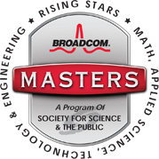
Taiwan Delegate Application
PART I. Student Information 基本資料 (請以中英文填寫)
This section student provides name address, contact information, teacher, project title, and other general information.
個資聲明：因本報名表所知悉、取得或蒐集之參賽者個人資料(包含但不限於自然人之姓名、出生年月日、家庭、教育、聯絡方式及其他得以直接或間接方式識別該個人之資料等)，博通將嚴守秘密並僅得於博通大師國際獎之必要目的範圍使用，並不得將前述資料以任何方式或形式為約定範圍外之重製、利用或向第三人揭露。並應依「個人資料保護法」等相關法律之規定處理。
Name
姓名
Gender
性別
Date of Birth
生日
Resident Address居住地址
Contact No.
聯絡電話
School
學校名稱
School Address
學校地址
School Tel.
學校電話
Teacher
教師姓名
Project Title
專題名稱
Other information
其他資訊
Broadcom MASTERS International
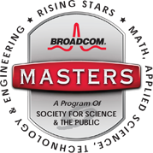
Taiwan Delegate Application
PART II. Project Information (請以英文填寫)
This section is essentially the core of the application. Please provide an explanation of your science fair project. Reflect on what had peaked your curiosity or interest in the topic. Remember that the judges have not seen your project board and can’t talk to you – so all they know about your project is what you tell them in these essays.
Title of project
Was this a team project? If yes, please list the name(s) of other team member(s). Each team member is eligible to enter the Broadcom MASTERS, and each entrant’s application will be judged on its own merits. It is possible that a team member will advance in the competition while another team member does not.
Brief description of project: under 500 words
Project Title

Team Project | Yes ; No
Team Member

Project Brief (Maximum 500 Words)

