教學活動設計
單元名稱 | Most of us wanted to eat at the Steak House |  | 班級 | 忠孝國中  8〇〇 | 人數 | 〇〇
教材來源 | Hanlin  Book4/U7 |  | 教師 | 東北區有效教學種子教師  第八組 | 時間 | 45mins
The background of students |  | They are the eighth graders in junior high school. Basically, they are familiar with past-tense grammar structure and can use simple English to describe their personal needs, willingness and feelings. And they can use English to express themselves and communicate with others.
Teacher’s philosophy of teaching this lesson |  | Through the inspiring story, students can relate the content to their relationship between the people who ever helped them. Students begin to know how to show their gratitude instead of taking everything from others for granted.
Teaching method |  | Communicative approach  Cooperative learning approach  Task-based approach
Teaching Aids |  | YouTube Video  Worksheets  Textbook
Enabling Objectives  1. Enable students to understand vocabulary about food.  2. Enable students to use indefinite pronouns.  3. Enable students to order their meals. | 分段能力指標  1-2-3 能聽懂日常生活對話和簡易故事。  2-2-2 能以簡易英語參與課堂上老師引導的誅論。  3-2-7 能辨識故事的要素，如背景、人物、事件和結局。  4-2-5 能依提示書寫簡短的段落。
Teaching Activities |  | Time | Teaching Aids | Evaluation
Pre-reading(Warm-up)(Motivation)  1. Divide students into groups.  2. Watch “我愛中國菜” on YOUTUBE.  3. Ask students to finish the Worksheet1 when watching “我愛中國菜”.  4. Ask students to watch “我愛中國菜” again and finish the Worksheet2.  5. Students share their answers in their group and teacher checks the answers.  6. Use Worksheet2 to review key words in Unit 7. |  | 10mins | YouTube  Worksheet1  Worksheet2 | Listening  Writing
While-reading  Activity1:  1. Ask students to read and listen to the text.  2. Give students important sequence clues in the reading and ask several wh-questions to help students comprehend the main idea of the reading.  3. Ask students to listen to the text again and finish the worksheet3 (reading structure) at the same time.  4. Ask students to share their answers in their group and teacher check the answers.  Activity2:  1. Give students the scrambled lines of the text and ask them to put them in the correct order without reading the text.  2. Ask students to share their answers in their group. |  | 15mins  10mins | Textbook  Worksheet3  Scrambled lines of the text | Listening  Writing
Post-reading(Assessment)  1. Ask each group to create a short conversation about ordering meals.  1) There should be different roles in the conversation, such as the waiter and the customers.  2) The customers can be family, lovers, friends or classmates.  2. Ask students to play their roles in the conversation during the next period.  3. Ask students to write the reflection about their short conversation and finish the evaluation sheet. |  | 10mins | Worksheet4 | Oral  Presentation  Writing

Worksheet 1.
Circle the dishes you hear

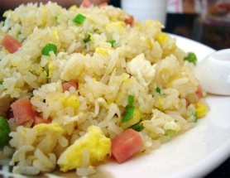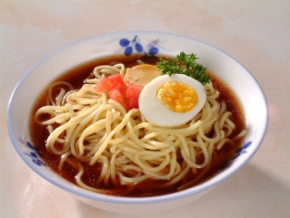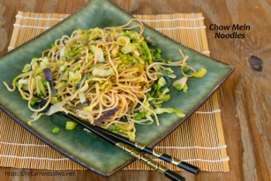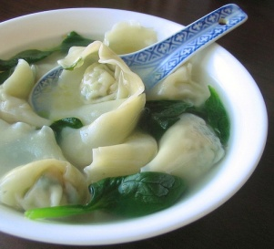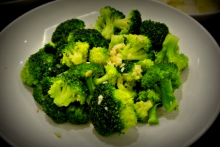

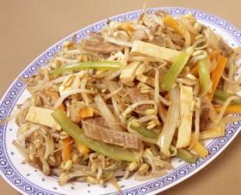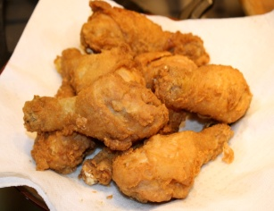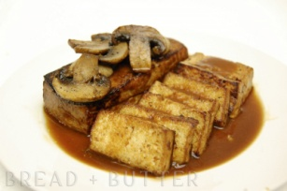

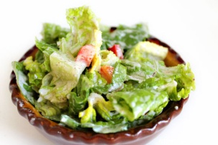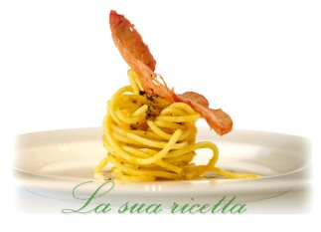

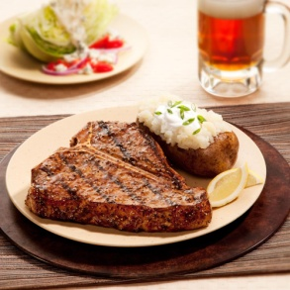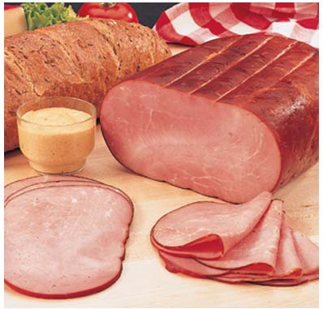

Worksheet 2.
Again! Circle the dishes you hear.
Chinese Food

fried rice noodles chow mein wonton soup fried broccoli
(fried noodles)

egg roll(spring roll) chop suey fried chicken legs tofu steam fish
(spicy hot)

Western Food
hamburger pizza salad spaghetti pasta
steak hot dog corn soup french fries ham

Worksheet3
B4 U7 Reading Structure (Worksheet) Class: _________ Group No.:__________
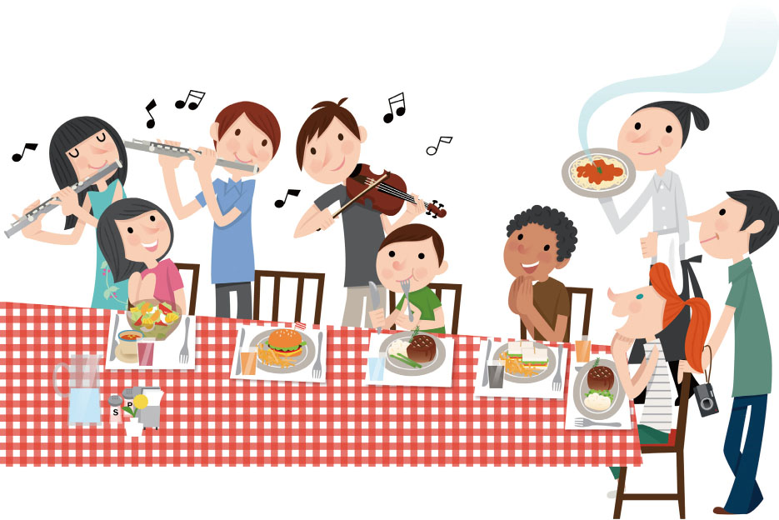

Complete the structure of the reading:
Where?
Who?
What did they do at the party?
Some:
The other members:
How did they feel? | Everyone
At the end | A waiter _____________________________________  Everyone laughed happily.

B4 U7 Reading Structure(Answer Sheet)

Complete the structure of the reading.
Where? | A party at yummy steak house.
Who? | School band members.
What did they do at the party?
Some: | Some brought flutes and violins (played songs).
The other members: | The other members sang with the music.
How did they feel? | Everyone had a good time eating and talking.
At the end | A waiter took a picture for them.  Everyone laughed happily.

Scrambled lines of the text
The school band had a party at Yummy Steak House this afternoon.
Some of the band members played a few songs with their flutes and violins
, while the other members sang with the music.
During that time,
everyone had a great time eating, talking and enjoying all of the delicious food.
Many of the members
stayed at the steak house until it was dark.
At the end of the party,
the band teacher asked a waiter to take a picture for them.
Everyone laughed happily. What a nice party!
1.
2.
3.
4.
5.
6.

- The school band had a party at Yummy Steak House this afternoon.
- Some of the band members played a few songs with their flutes and violins, while the other members sang with the music.
- During that time, everyone had a great time eating, talking and enjoying all of the delicious food.
- Many of the members stayed at the steak house until it was dark.
- At the end of the party, the band teacher asked a waiter to take a picture for them.
- Everyone laughed happily. What a nice party!

Worksheer4
英語領域學習單
活動名稱：Restaurant English餐館英語短劇
年 班 座號 姓名

一.英語短劇劇本：
﹡請設定一個在餐廳中點餐的情境，角色應包含服務生與客人，並使用本課所學到的【菜色單字】和【不定代名詞】於對話中。
(Script)

二.自評互評表：
請為演出的同學打分數。依以下5個等第勾選。（最好到最差）
評分學生： 年 班 號 姓名： 所屬組別：第 組
等第  組別 | （5）  Excellent | （4）  Very good | （3）  Good | （2）  Not bad | （1）  poor
第 1 組
第 2 組
第 3 組
第 4 組
三.心得分享：
1.我演的角色是：
2.我覺得我的表現：□ 好 □普通 □差
3.我的感想：（自由發揮）

