會議名稱：會考命題趨勢與閱讀命題技巧
日期 | 2014.09.22 | 地點 | 臺北市立忠孝國民中學 校史室
主持人 | 王巧媛校長 | 紀錄 | 林珮君
列席指導 | 陳秋蘭教授
出席者 | 出席教師詳見簽到表
會 議 內 容
13:30會議開始
I. 會考試題
- 單字：重語用、上下文、語意連貫、邏輯。
- 背文法公式(x)：prep+ V-ing 無法回答(24)Lexie _________ reading maps.
- 選項中應全為母音或子音開頭單字，避免a(n) _____的題幹。
- 語意相近的選項，考collocation：
  - e.g. (25)The problem is so serious. (o) The problem is so strong. (x)
- Fixed expression：eg. (26) Pass the test of time
- 給例句歸納，而非給規則。
Cf.(27) I’m not sure if Kevin will come in this morning, but if he does, I’ll tell him that you called.
If Kevin comes, I’ll tell him that you called.
中文例子：…呢？(wh問句)；…嗎？(yes-no 問句)
- 中文通英文不通：eg. (28)
I think the road ends here, it won’t go any farther. (o)
I think the road ends heare, it won’t go any longer. (x)
- 選項中不要有太明顯的對立答案：e.g. (33)falling vs. growing
- Local clues較簡單，但clues在後面的題目比較難，鼓勵學生read on for clues
- Maps: 常考題型
- Which is NOT said….? 此為四題是非題。
- 閱讀測驗之問題與文章須有wording difference：e.g. (38)
文章：I was able to look at the world around me with fresh new eyes.
題目：What can readers most likely learn from the book? (A) A new way of seeing the world.
- Online reading為學生須具備的能力e.g. (41). Where did Linda click on the homepage of Cheetah Car Racing 2014 to get to this page? (D) Join Our Work Team <= sorting
- 帶閱讀時領導學生作prediction、討論各種possibilities，(42-44)
Cecilia: Eddie’s having a tasting party this Saturday.
Gloria: No! <= Why?
- 引導學生欣賞文章的趣味。(42-44)
Cecilia: He said he wanted to share his newest cakes with his dearest friends.
Gloria: If he sees us as his dearest friends, he should stop having tasting parties! <=Gloria picks up Cecilia’s words.
- 教導學生口語之英文 (42-44)
  - Gloria: So we still have to lie at his pary again? <= 直述句成為問句，和學生討論使用的context
- 選擇題選向盡量一樣長，balance the distracors ：
- (43) (A) (B) 選項問關於Cecilia的問題；(C) (D) 選項問關於Gloria的問題
- 考inference (45) Where does Josie work? 找文章限索:
- We wear white all the time.
- People kept coming in and asked for our help because they got hurt.
II. 給國中教師的建議：
- 老師們共同討論段考試題，針對考題而非針對個人。
- 段考為acheivement test，但可在考題中考一篇reading comprehension text 測試reading comprehension skills
- 減少練習不會用到的語言例句：e.g. I bought a book. -> The book is bought by me. (x)
- 七年級學生給予reading materials，八、九年及學生在開始練習reading comprehension tests。閱讀時總是得回答comprehension questions扼殺閱讀的樂趣。
- 學生學習閱讀information text，但narrative stories仍不須荒廢。
- 學生需大量閱讀，培養看文章與題目的耐心。
- 課本閱讀教學可從找每一段落的main ideas 開始。
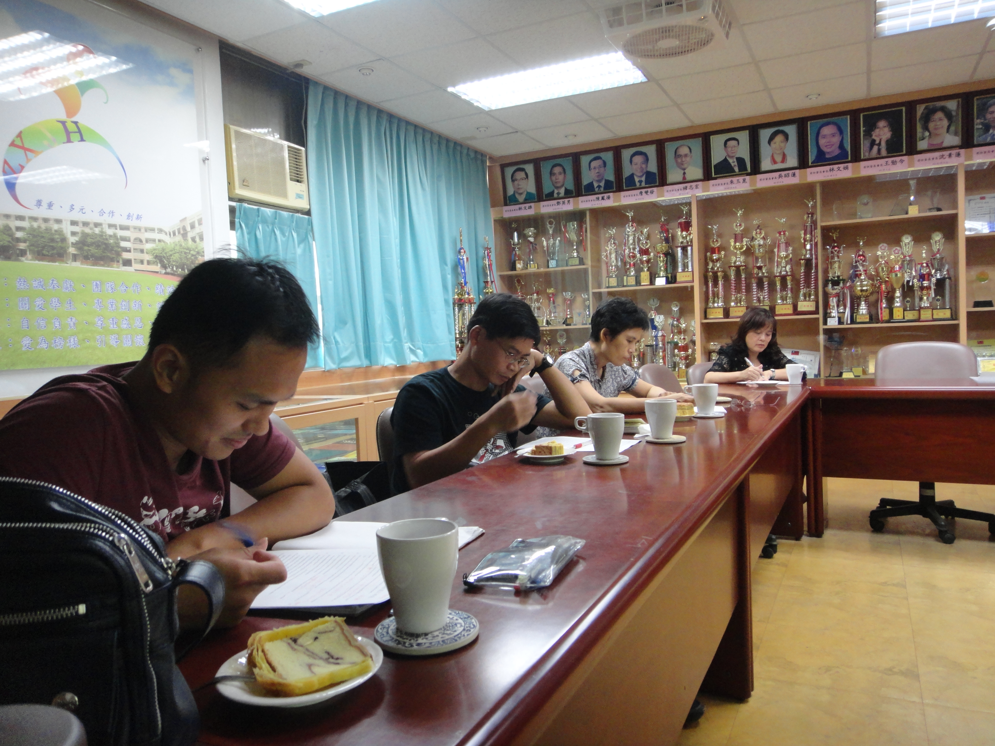
15:50會議結束
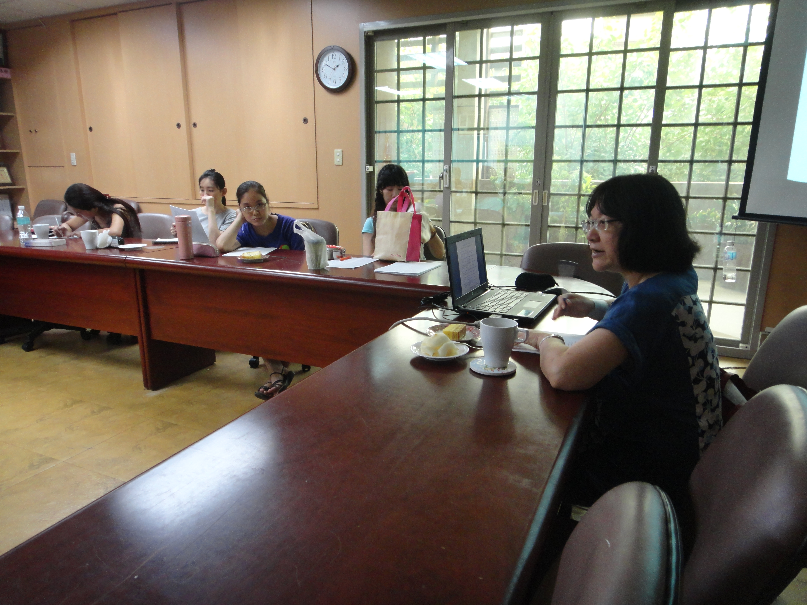
陳秋蘭教授講解會考命題 團員認真研究會考試題

13:30會議開始
I. 會考試題
- 單字：重語用、上下文、語意連貫、邏輯。
- 背文法公式(x)：prep+ V-ing 無法回答(24)Lexie _________ reading maps.
- 選項中應全為母音或子音開頭單字，避免a(n) _____的題幹。
- 語意相近的選項，考collocation：
  - e.g. (25)The problem is so serious. (o) The problem is so strong. (x)
- Fixed expression：eg. (26) Pass the test of time
- 給例句歸納，而非給規則。
Cf.(27) I’m not sure if Kevin will come in this morning, but if he does, I’ll tell him that you called.
If Kevin comes, I’ll tell him that you called.
中文例子：…呢？(wh問句)；…嗎？(yes-no 問句)
- 中文通英文不通：eg. (28)
I think the road ends here, it won’t go any farther. (o)
I think the road ends heare, it won’t go any longer. (x)
- 選項中不要有太明顯的對立答案：e.g. (33)falling vs. growing
- Local clues較簡單，但clues在後面的題目比較難，鼓勵學生read on for clues
- Maps: 常考題型
- Which is NOT said….? 此為四題是非題。
- 閱讀測驗之問題與文章須有wording difference：e.g. (38)
文章：I was able to look at the world around me with fresh new eyes.
題目：What can readers most likely learn from the book? (A) A new way of seeing the world.
- Online reading為學生須具備的能力e.g. (41). Where did Linda click on the homepage of Cheetah Car Racing 2014 to get to this page? (D) Join Our Work Team <= sorting
- 帶閱讀時領導學生作prediction、討論各種possibilities，(42-44)
Cecilia: Eddie’s having a tasting party this Saturday.
Gloria: No! <= Why?
- 引導學生欣賞文章的趣味。(42-44)
Cecilia: He said he wanted to share his newest cakes with his dearest friends.
Gloria: If he sees us as his dearest friends, he should stop having tasting parties! <=Gloria picks up Cecilia’s words.
- 教導學生口語之英文 (42-44)
  - Gloria: So we still have to lie at his pary again? <= 直述句成為問句，和學生討論使用的context
- 選擇題選向盡量一樣長，balance the distracors ：
- (43) (A) (B) 選項問關於Cecilia的問題；(C) (D) 選項問關於Gloria的問題
- 考inference (45) Where does Josie work? 找文章限索:
- We wear white all the time.
- People kept coming in and asked for our help because they got hurt.
II. 給國中教師的建議：
- 老師們共同討論段考試題，針對考題而非針對個人。
- 段考為acheivement test，但可在考題中考一篇reading comprehension text 測試reading comprehension skills
- 減少練習不會用到的語言例句：e.g. I bought a book. -> The book is bought by me. (x)
- 七年級學生給予reading materials，八、九年及學生在開始練習reading comprehension tests。閱讀時總是得回答comprehension questions扼殺閱讀的樂趣。
- 學生學習閱讀information text，但narrative stories仍不須荒廢。
- 學生需大量閱讀，培養看文章與題目的耐心。
- 課本閱讀教學可從找每一段落的main ideas 開始。
15:50會議結束

陳秋蘭教授講解會考命題分析 團員認真研究會考命題

