年齡和形容詞 100.10.07
Class：__________ No：__________ Name：_______________
- 寫出下列圖片的形容詞
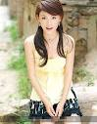  _______________ |   _______________ | 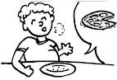  _______________
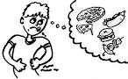  _______________ | 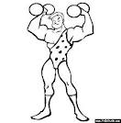  _______________ | 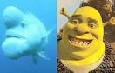  _______________
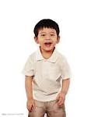
_______________

- 回答下列問題
- How old is your father?
____________________________________
- Is she pretty? (肯定詳答)
____________________________________

